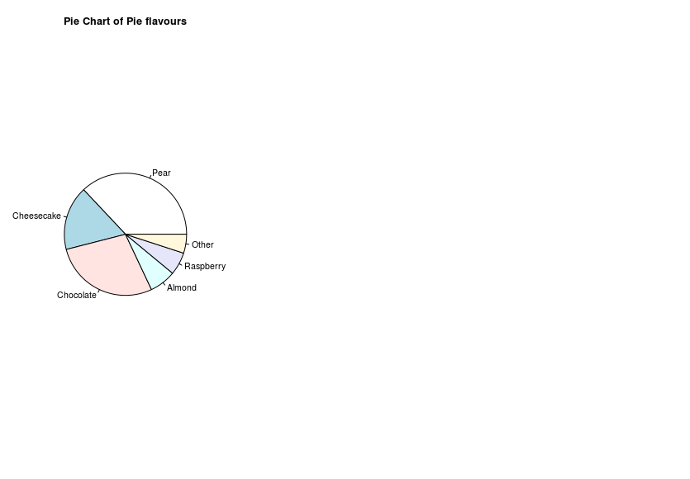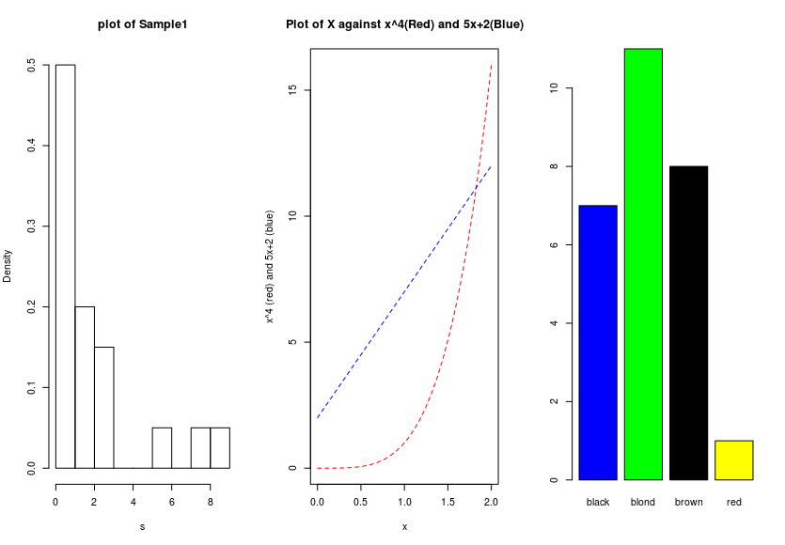Lucas Faijdherbe(2594812) & Ruben van der Ham(2592271) – CS40

**Assignment 0**

**Exercise 0.6**

**Exercise 0.7**

1. **We suppose we get a vector containing only 0’s and 1’s (So in this case, a vector with 30 0’s and 70 1’s)**

function.sample1 <- function(vase){

u = sample(vase,50,replace = TRUE, prob = NULL);

reds = length(u[u<1]);

whites = length(u[u>0]);

fractions = c(reds/50, whites/50);

return(fractions);

}

1. function.sample2 <- function(n = 10, mr = 30, mw = 70){

redBalls = rep(0,mr)

whiteBalls = rep(1,mw)

vase = c(redBalls,whiteBalls)

u = sample(vase,n,replace = TRUE, prob = NULL);

reds = length(u[u<1]);

whites = length(u[u>0]);

fractions = c(reds/n, whites/n);

return(fractions);

}

1. function.sample3 <- function(){

x = 1:200;

for (i in 1:200) {

u = sample(1:90,40, prob = NULL);

x[i] = median(u);

}

return(u);

}